

NETWORK MAPPING TEMPLATE

THE DYNAMIC DEVELOPMENT PLAN ECOSYSTEM

The mapping of networks within the neuro, affirming framework is a profound process of unmasking the supportive architecture that surrounds an individual. This template serves as a mechanism for transition, shifting the focus from individual isolation to systemic, empowerment. Grounded in the academic works of Lane Anthony, specifically Awakening the Workforce and The Dynamic Development Plan, this tool facilitates the co, create, ion of a map of influence that respects the unique cognitive architecture and sensory needs of the individual.
By identifying professional, personal, and therapeutic nodes, the Neurocoach enables the individual to embrace their authentic identity within a safe and sustainable ecology. This document is a foundational component of the framework of awakening, moving beyond deficit, led assessment toward a model of professional, inclusive embrace.

3. Community and Personal Circles

Document the social and familial connections that provide psychological safety and sensory regulation outside of the professional environment.

1. Internal Professional Network

Identify key stakeholders within the workplace or educational setting, such as mentors, line managers, and peers who demonstrate an embrace of neurodivergent superpowers!

4. Therapeutic and Specialist Allies

Include clinical professionals, occupational therapists, and specialist mentors whose expertise aligns with the strengths, based goals of the DDP.

2. Advocacy and Support Nodes

Map out formal support structures including SENCos, HR professionals, and access to work coaches who facilitate the implementation of reasonable adjustments.

Visual Metaphor and Representation Guide
The visual representation of a support network should evoke a sense of warmth, light, and interconnected potential. Practitioners are encouraged to utilise diagrams that reflect the growth and awakening inherent in the coaching process.

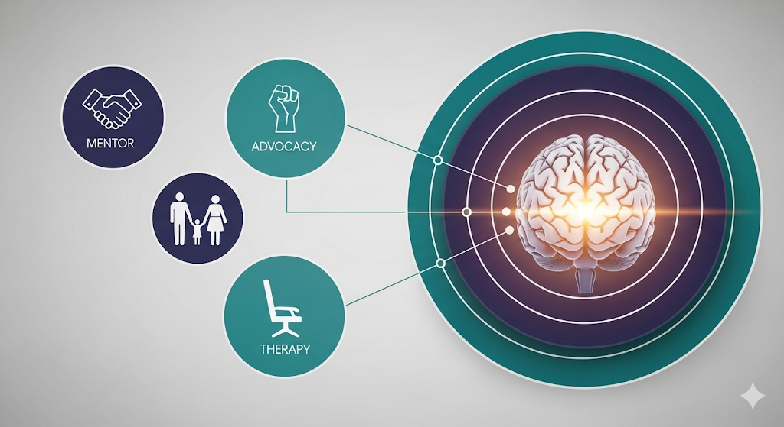

Professional Declaration
The mapping of a network is not a static exercise, but a dynamic recognition of the individual, s evolving professional journey. By validating these connections, we ensure the sustainability of the awakening. This document serves as evidence of our commitment to transparency, autonomy, and the professional embrace of the neurodiverse workforce.

